Assignment name: Assignment 2

Student name:

Student ID:

Tutor:
Table of Contents

Introduction 3

I. Development documentation 4

II. IDE evaluation 6

III. Debugging evaluation 6

IV. Coding standard evaluation 7
Introduction

With the task at hand being to develop an application form in an Integrated Development Environment which includes basic functions such as: adding information, updating information and search for an existing patient, this report will demonstrate how basic algorithms can be implemented into code using an IDE, determine the debugging process and analyse the important of a coding standard.

I. Development documentation

The development of this application form first started at the Visual Studio start page which allows users to personalize the design of the IDE and open and create new projects.
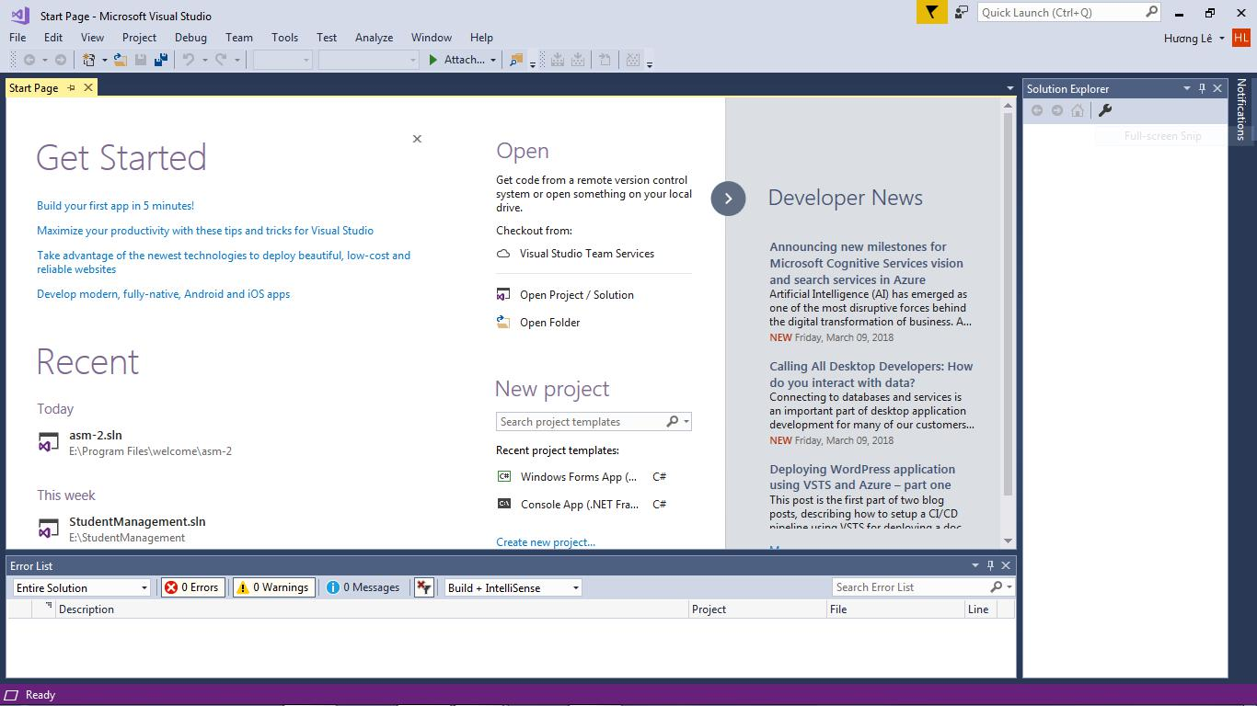

Figure 1: Microsoft Visual Studio start page
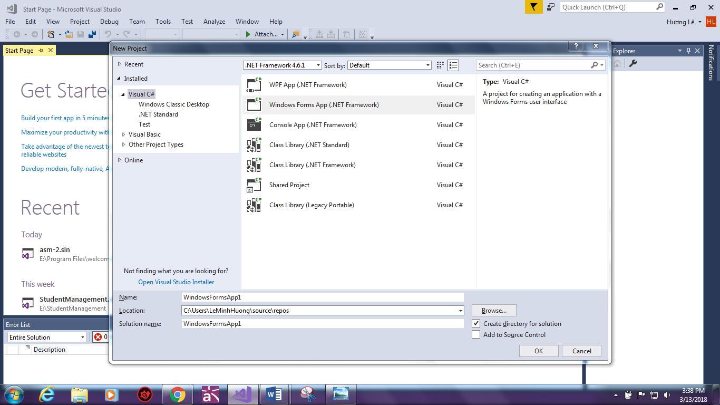

Figure 2: Creating a new project in VS.

Now proceed to the form designer page where most of the coding happens. As seen in figure 3, the form properties are highly visualized and easy to maneuver.
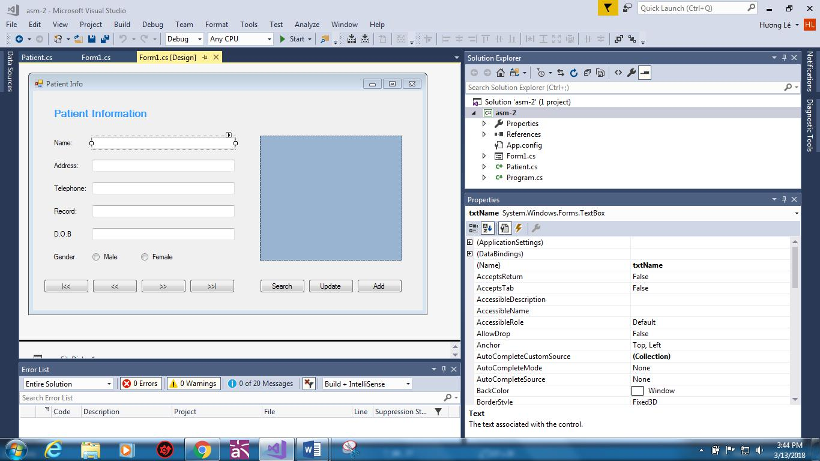

Figure 3: The form properties.
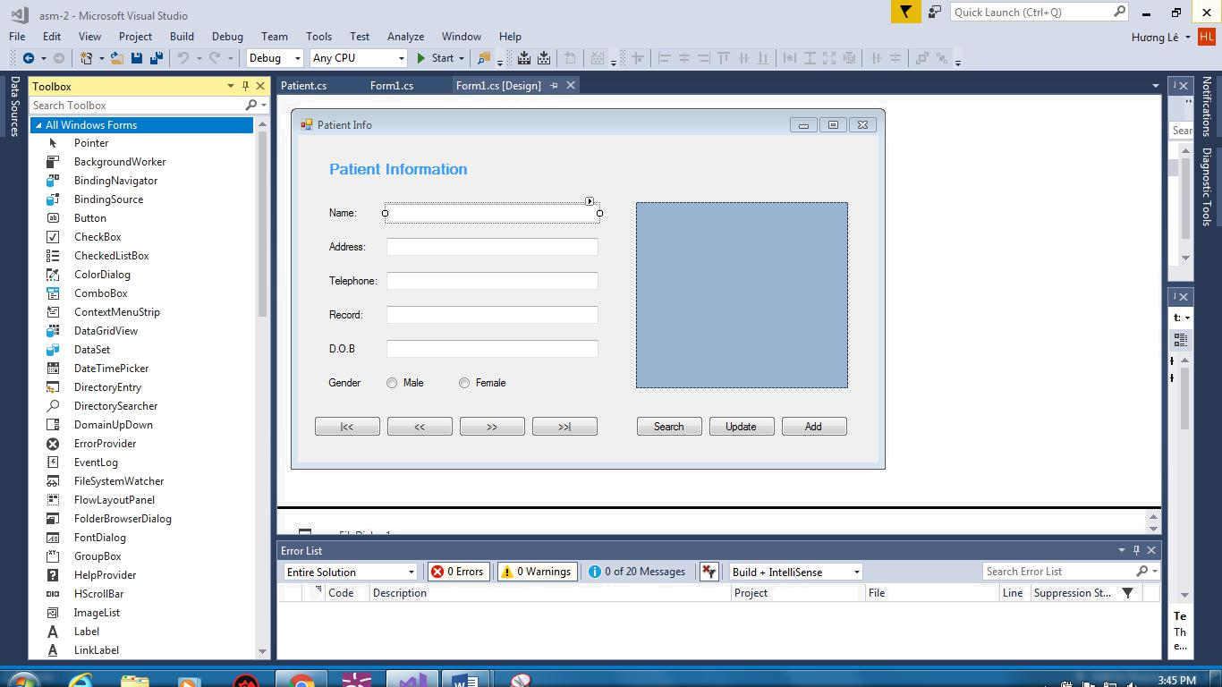

Figure 4: Adding components to the form.

While visual components may be added by the simple drag-drop from the toolbox, non-visual components will be added to a list underneath the form. As you include components, the IDE creates code in your form's InitializeComponent method, simply choose your component’s event and you can edit the code below.

II. IDE evaluation

IDEs are especially designed programs to increase work efficiency by providing extensive tools and platforms to computer programmers for software development. Using an IDE for coding is advantageous because it grants programmers the power to do everything in one environment through one graphic interface instead of using a number of singular programs; ultimately saving a lot of effort and time.

As for non-IDE developing environment, though more extensible and easily personalized, they are often standalone text editors which do not provide programmers with as much support as IDEs because they do not come with a built-in compiler and the debugging process will have to be done by hand.

III. Debugging evaluation

Debugging is an essential stage in program development that includes finding a defect and then fixing or deciding on a way to establish a workflow that may prevent the problem from happening.

Once your code is complete and ready, you may start a debugging session using the Debug (F5) command which will start your application with the debugger attached. Some of the noticeable debugging facilities in an IDE include:

- Adding breakpoint (F9): is used to notify debugger where and when to pause the execution of the program. After the debugger hits the breakpoint, you may need to execute the code line by line to find other defects.

- Step over (F10): is the command to execute the code line by line.

- Step into (F11): similar to Step Over, the difference being if the current highlighted section calls out to any methods, the debugger will go inside that method.

- Step Out (Shift – F11): the execution will complete the execution of said method and pause at the next statement from where it is called.

- Run to cursor: setting a temporary breakpoint.

With these tools in hand, debugging has become a far easier task since they allow programmers to skip and repeat certain parts of the code, step into an object’s insides, correct your code while the program is executing and instantly notice the change, etc. therefore eventually let the programmer know if the code accords to the path they want it to take and save them a lot of time and energy.

IV. Coding standard evaluation

One definition of coding standard maybe “a collections of instructions for a particular programming language that advise on programming design, systems and methods for individual prospect of a program”. Programmers are suggested to follow these instructions in their professional projects and daily coding practice because of the following benefits:

- Improve development speed: Programmers are set to follow precedents instructions.

- Decrease code complexity, increase code quality: Coding standards helps simplify code and therefore minimize defects.

- Easier debugging process: Writing your code in a clean and comprehensible style will assists programmers in spotting and fixing bugs a lot, avoiding spending a significant amount of time in resolving issues that could have been prevented.

- Reusable and less money-comsuming: A clear simplified code has the potential to be reused in other projects, which eventually lower the cost and the development effort.

Examples of coding standard being use in patient's information form are comment on fuction headers, names chosen, spacing and alignment format, names representing methods or functions must be verbs and written in mixed case starting with upper case, names representing a collection of objects are in plural form, the prefix n should be used for variables representing a number of objects, the using of white spaces and logicl units.
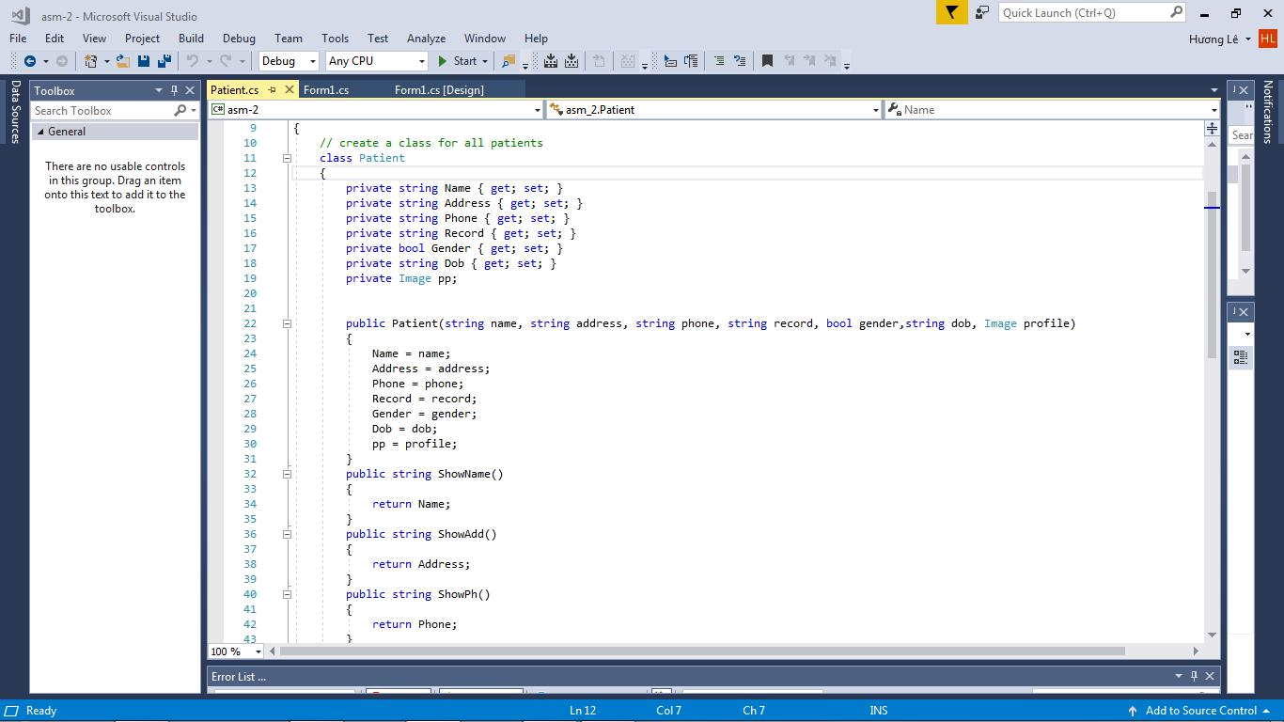

Figure 5: Coding standard example
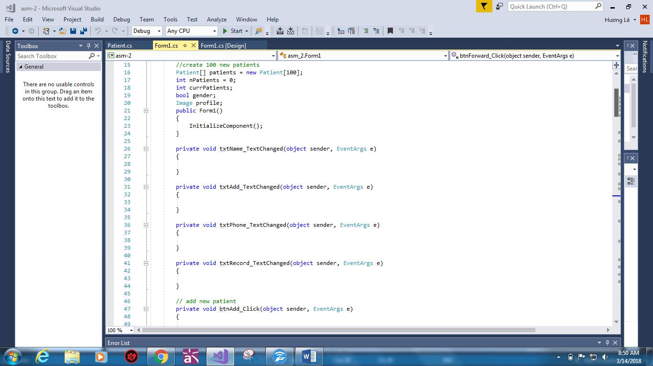

Figure 6: Example of coding standard

